**STUDENT MANAGEMENT SYSTEM**

**A PROJECT REPORT**

***Submitted by***

# JHA SHUBHAMKUMAR (ET23MTCA020)

# SHAH RUCHITKUMAR (ET23MTCA060)

# SOLANKI KHUSHALKUMAR (ET23MTCA062)

Under the Guidance Of

Prof. Preksha Parmar

***In fulfillment for the subject Software Project-1 (MTCA16106)***

# Master of Computer Application



At

Sarvajanik College Of Engineering & Technology, Surat

December, 2023

|  |  |  |
| --- | --- | --- |
| SCET ARCHITECTURE | **Sarvajanik Education Society**  **Sarvajanik College of Engineering & Technology, Surat.**  **Master of Computer Application Department Academic Year 2023-24** | A description... |

Date: 22/12/2023

# CERTIFICATE

This is to certify that the project entitled “STUDENT MANAGEMENT SYSTEM” has been submitted by JHA SHUBHAMKUMAR (ET23MTCA020), SHAH RUCHITKUMAR (ET23MTCA060), SOLANKI KHUSHALKUMAR (ET23MTCA062) towards fulfillment for the subject Software Project – I (MTCA16106) in 1st Semester of MCA of Sarvajanik University, Surat during the academic year 2023-24.

|  |  |
| --- | --- |
| **Guide Name: Prof. Preksha Parmar** | |
| **(Guides’ Signature)** | **Prof. Gayatri Kapadia Head, M.C.A. Department** |

|  |
| --- |
| **Examiners’ Signature:**  **1.** |
| **2.** |

**Acknowledgement**

|  |  |
| --- | --- |
| **Index** | **Page. No.** |
| 1. Abstract |  |
| 2. Software Specification |  |
| 3. Scope &Objectives |  |
| 1. DataBase Design    1. UseCase Diagram    2. Activity Diagram    3. ER Diagram |  |
| 1. System Design    1. screenshot |  |
| 6. References |  |

**1. Abstract**

**2. Software Specification**

**Operating System:**

* The Student Management System is designed to operate smoothly across all major platforms like Windows, macOS and Linux.
* Compatibility with diverse operating systems ensures accessibility for a broad user base.
* Whether users are on Windows, macOS or Linux the system guarantees a consistent and reliable performance.

|  |  |
| --- | --- |
| **Operating system** | * Microsoft windows 7 or above * Ubuntu 16.04 LTS or above * MacOS 12 or above |

**Hardware Configuration:**

**Processor:**

* The Student Management System is optimized for a minimum Intel Core i3 processor, ensuring responsive performance during runtime.

|  |  |
| --- | --- |
| **Processor** | Intel i3 or higher |

**RAM:**

* A minimum of 4 GB RAM is recommended to provide a smooth and efficient user experience while handling files and processing data.

|  |  |
| --- | --- |
| **RAM** | 4GB or higher |

**Storage:**

* The system requires approximately 128 GB of storage space, accommodating the application's executable files and data storage for student and teacher’s records.

|  |  |
| --- | --- |
| **Storage** | 128 GB or higher |

**Development Environment:**

* The Student Management System is designed to be developed and compiled using the Dev C++, Turbo C or Visual Studio integrated development environments (IDEs).

|  |  |
| --- | --- |
| **Development Environment** | Dev C++, Turbo C or Visual Studio |

**Programming Language:**

* This system is implemented in the C programming language, ensuring compatibility with the compilers provided by Dev C++ or Turbo C.

|  |  |
| --- | --- |
| **Programming Language** | C OR C++ |

**3. Scope & Objectives**

The primary objective of the Student Management System is to store and maintain student and teacher’s data efficiently through console-based application. This system aims to achieve operational excellence by providing a centralized platform for managing various activity of school or colleges through this application.

In this system real-time data updation is done into the files. The main goal of the Student Management System is to improve the accuracy and efficiency in the student records management.

The system is developed for Administration Staff, Teacher and Student to maintain records. The Administration Staff is the main user of this system. They can access all the data related to student and teachers and they can manipulate it according to their needs. They can manage course details, teacher’s details, students detail along with this an additional fee payment facility is also given in this applicaton.

In the context of the Student Management System, the aim is to provide administration staff with a convenient and straightforward method for maintaining records through the command-line interface. This eliminates the need for maintaining physical files or books with the goal of enhancing accessibility.

The goal of this system is to increase administrative efficiency by simplifying the data maintaining process.

Through streamlined reservation handling and automated updates, the Console Table Booking System reduces the workload on restaurant staff, leading to quicker and more accurate reservation processing.

**4. Database Design**

**File System for Data Storage**

* The Student Management System uses file system as the primary mechanism for storing and managing student’s and teacher’s data.

**File Structure:**

|  |
| --- |
| **Course Detail** |
| Course ID |
| Course Name |
| Fees |
| Subjects [6] |

|  |
| --- |
| **Teacher Detail** |
| Teacher ID |
| Name |
| Department |
| Date of Joining |
| Salary |
| Mobile No |
| Email |
| Password |

|  |
| --- |
| **Student Detail** |
| Enrollment No |
| Name |
| Date of Birth |
| Department |
| Mobile No |
| Email |
| Password |
| Fee |
| Marks [Subject] [6] |

**4.1 Use Case Diagram**

**4.2 Activity Diagram**

**4.3 ER Diagram**

**5. System Design**

**5.1 Screenshot**

**Welcome Page**

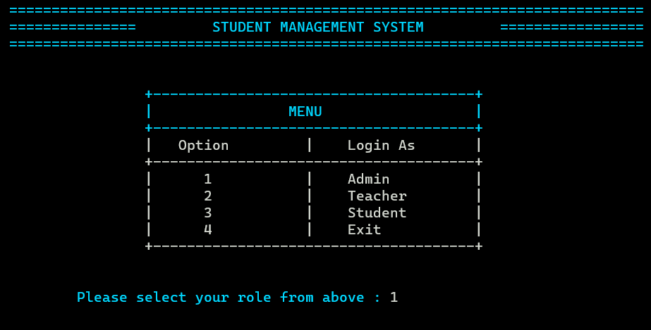

**Admin Login**

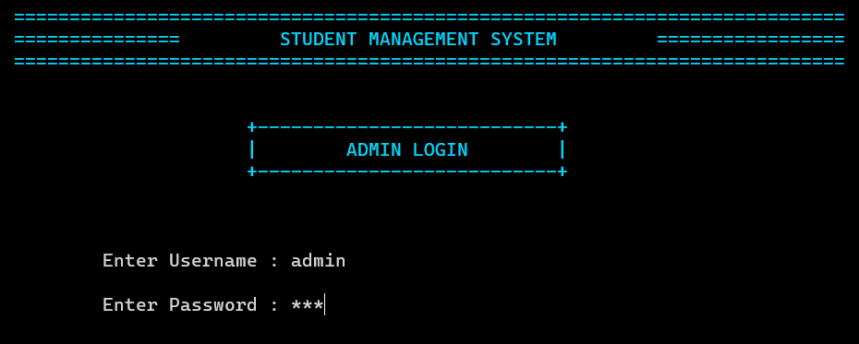

**Admin Dashboard**

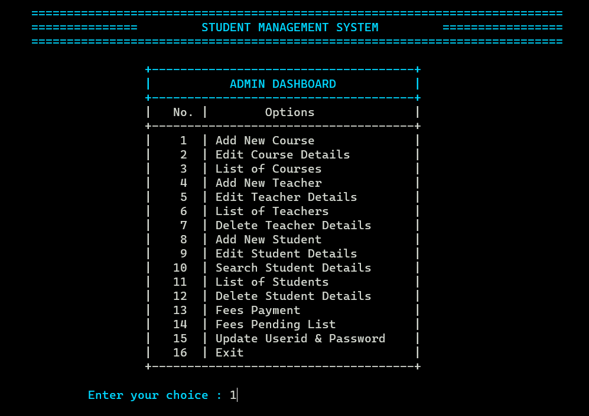

**Add New Course**

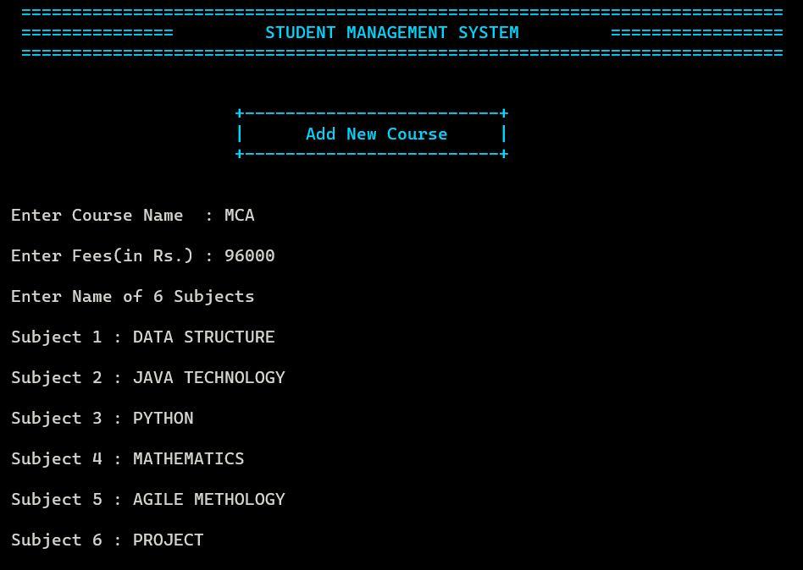

**Course Added**

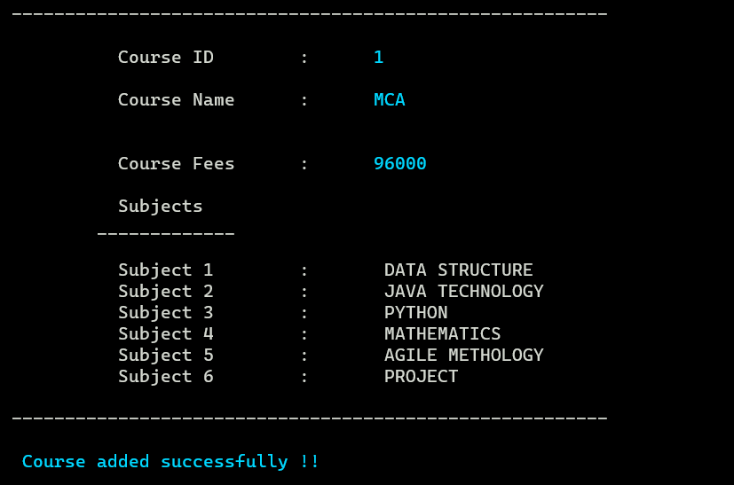

**Course List**

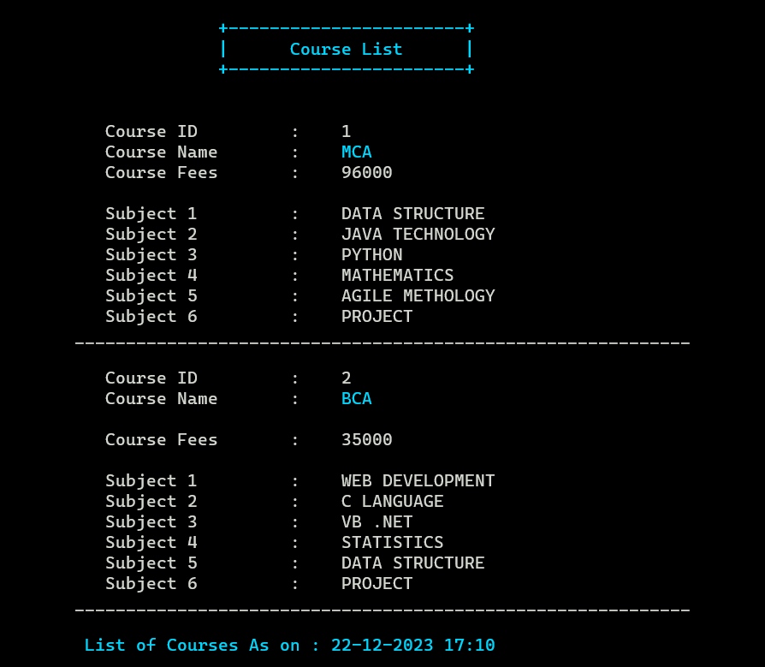

**Add New Teacher**

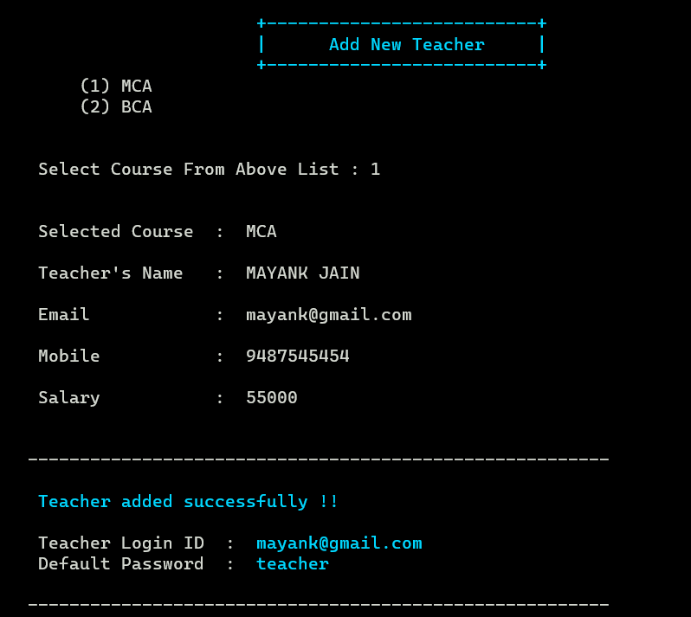

**Teacher’s List**

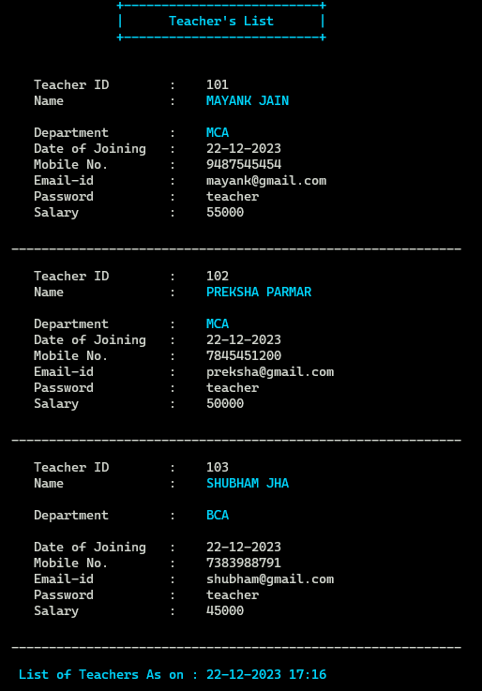

**Edit Teacher Details**

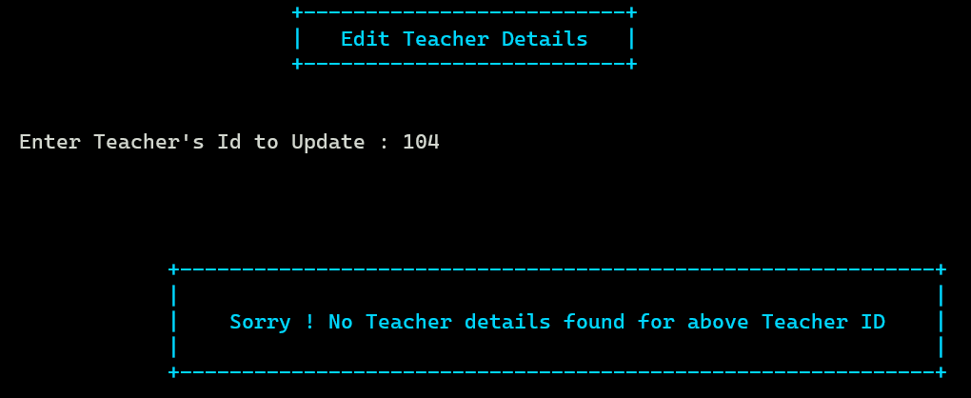

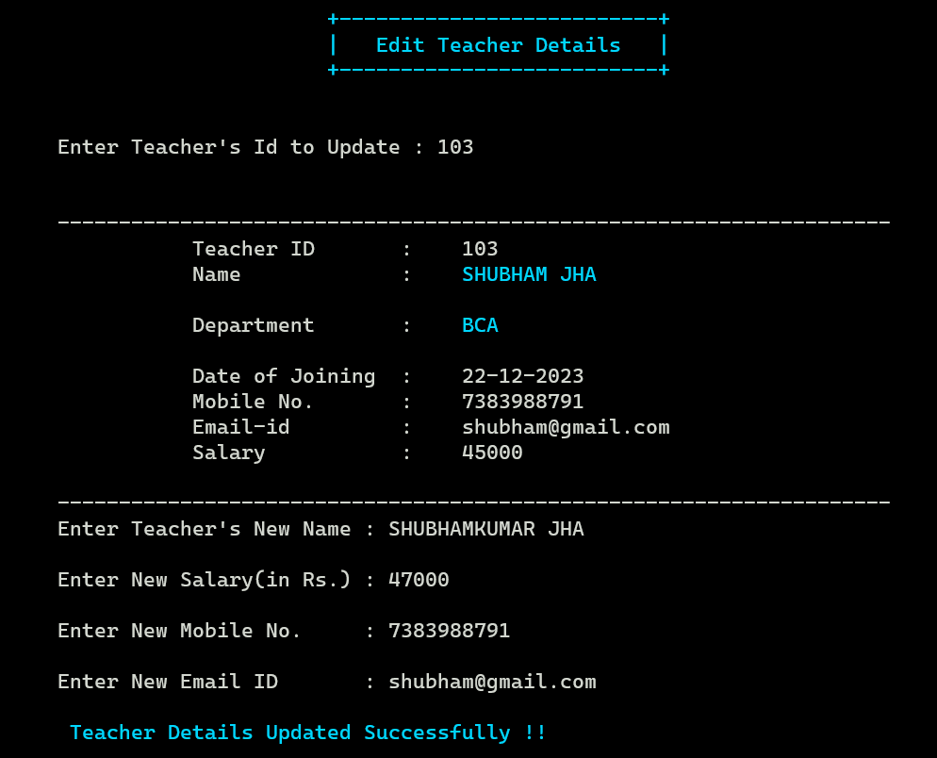

**Delete Teacher Details**

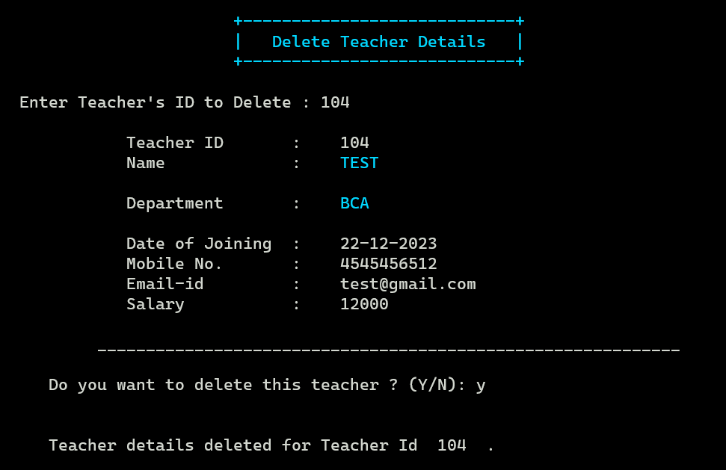

**Add New Student**

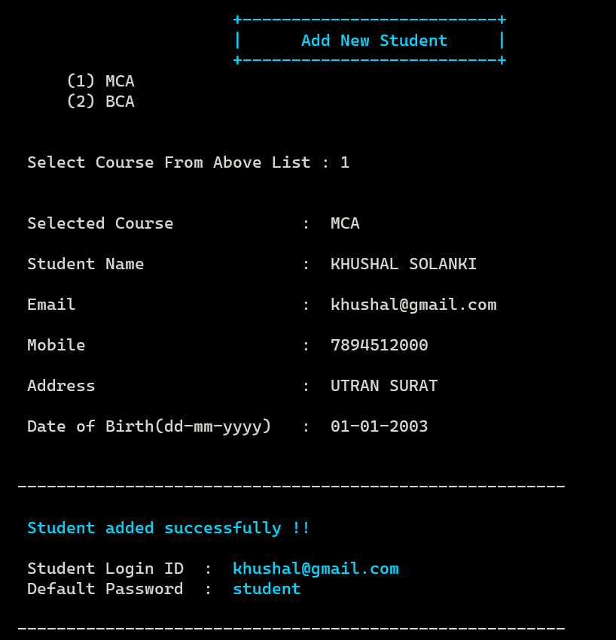

**Student List (Course wise)**

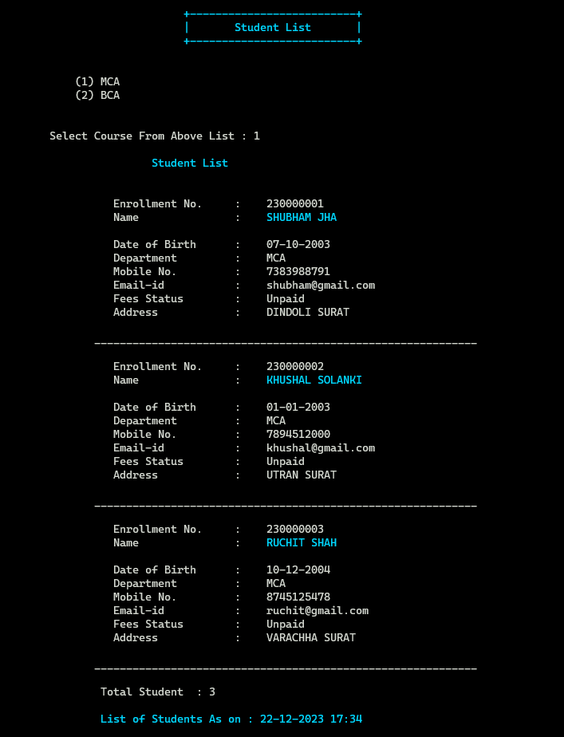

**Student List (Course wise)**

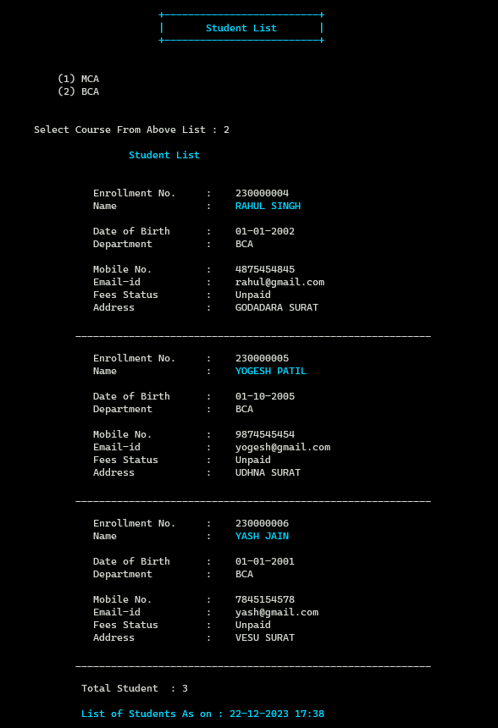

**Edit Student Detail**

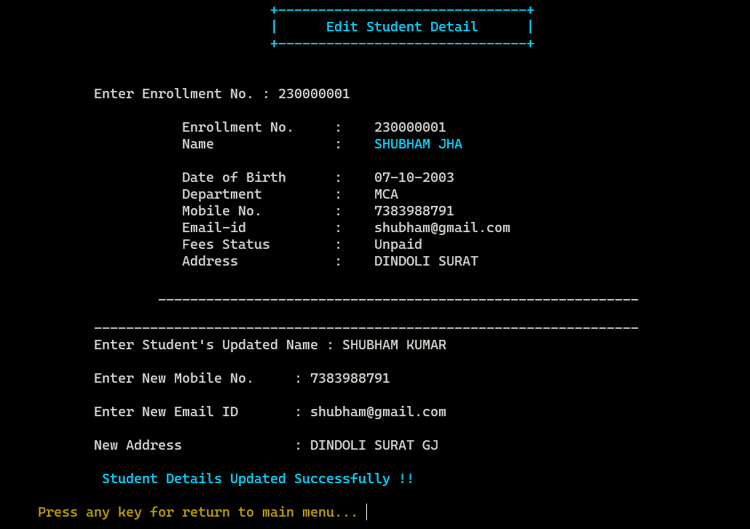

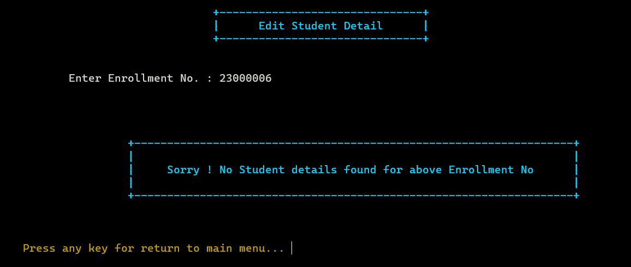

**Search Student By Enrollment No.**

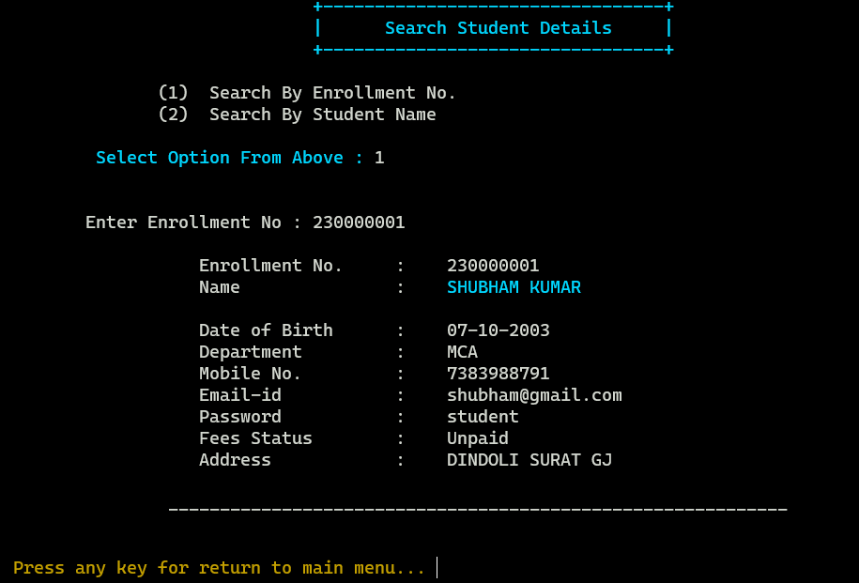

**Search Student By Name**

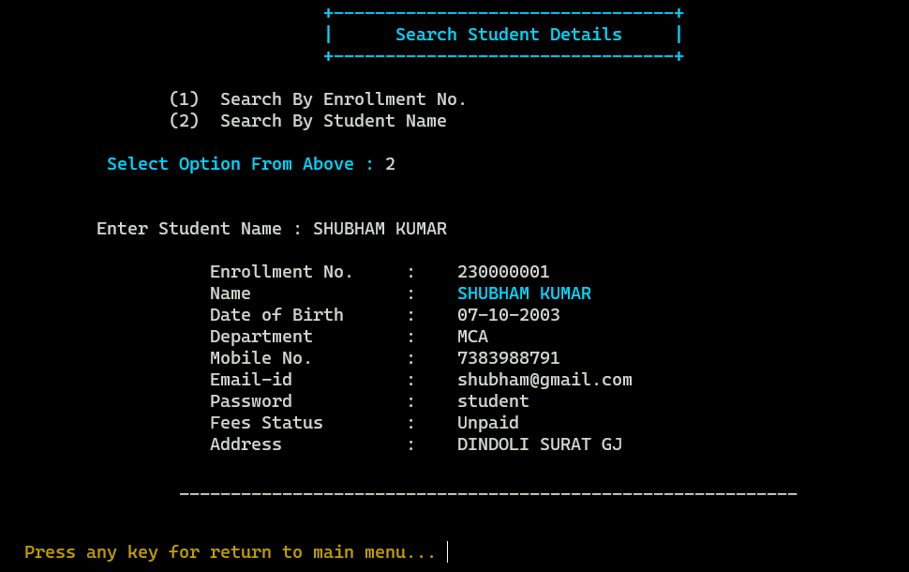

**Delete Student Detail**

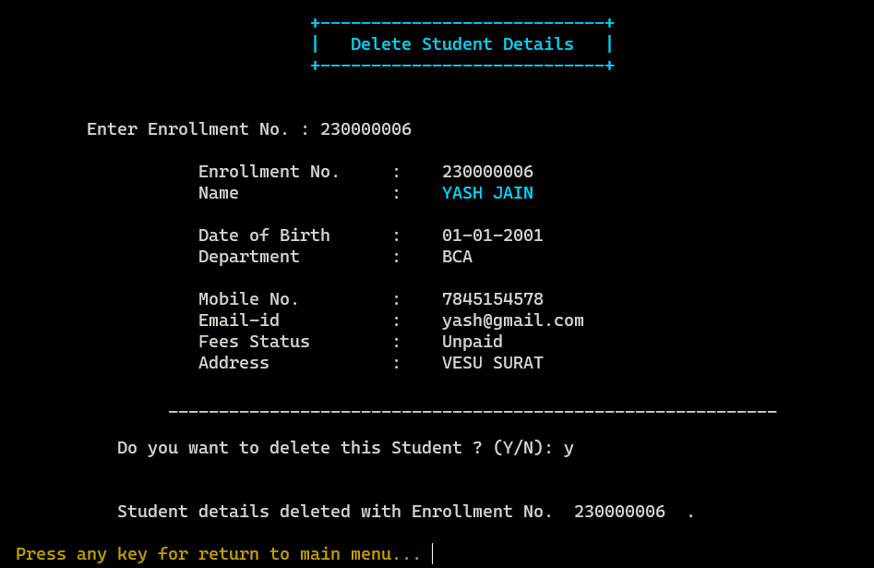

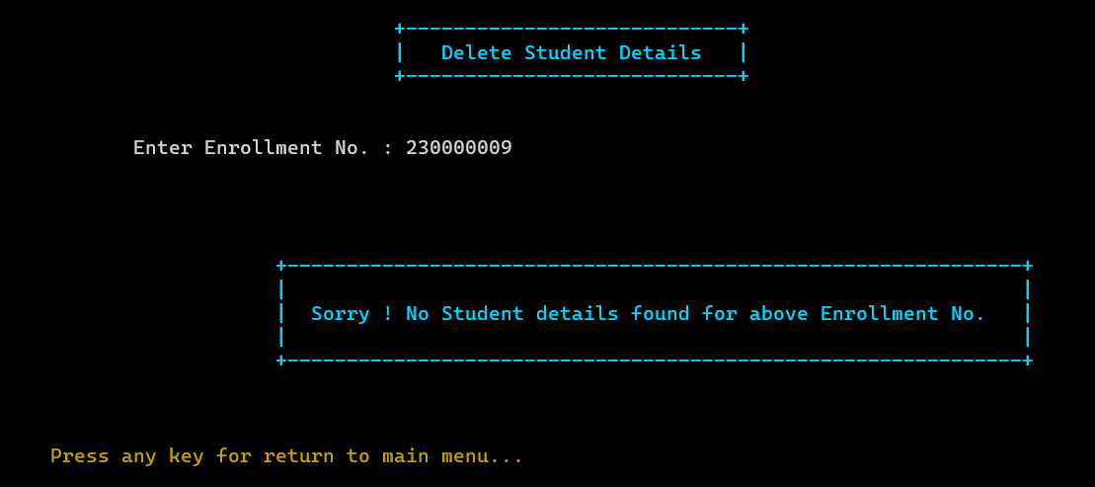

**Fees Payment**

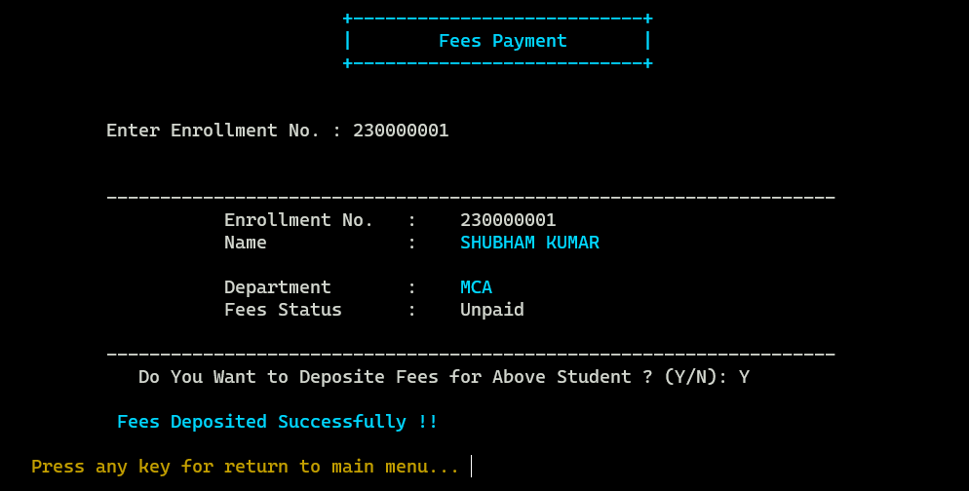

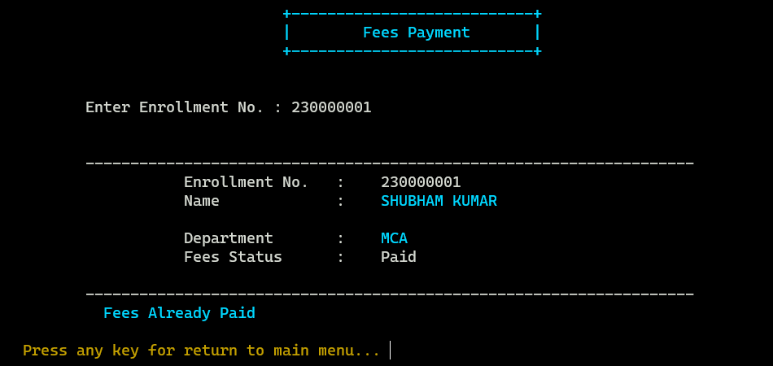

**Fees Pending List (Course wise)**

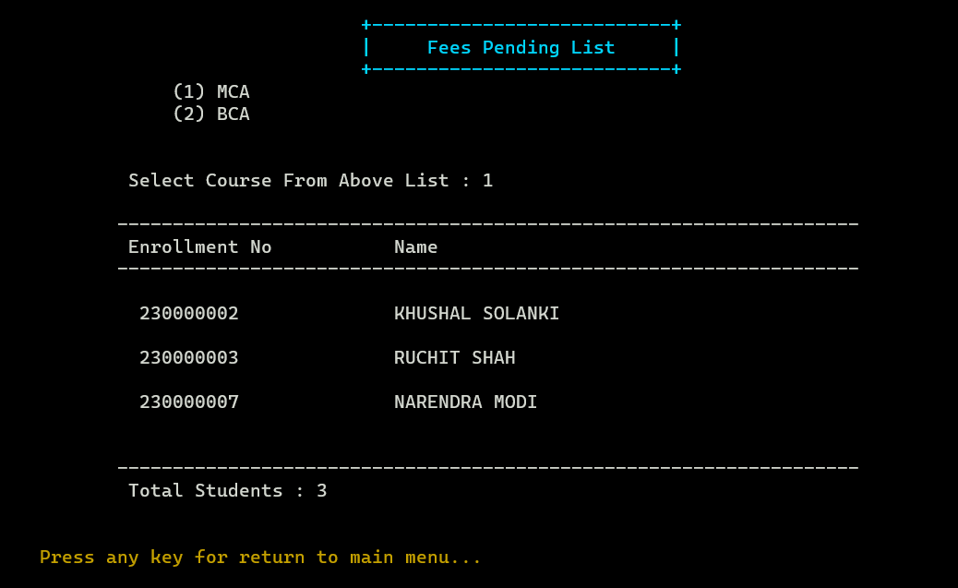

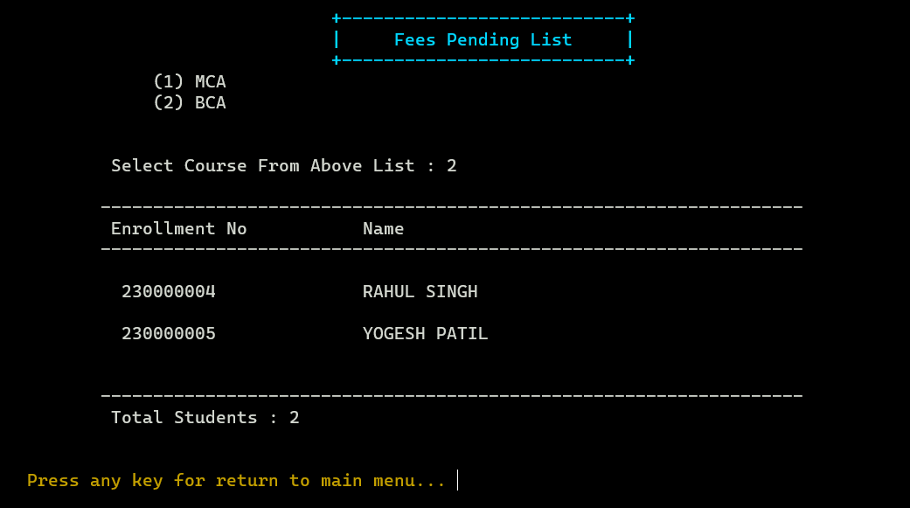

**Update Admin Credentials**

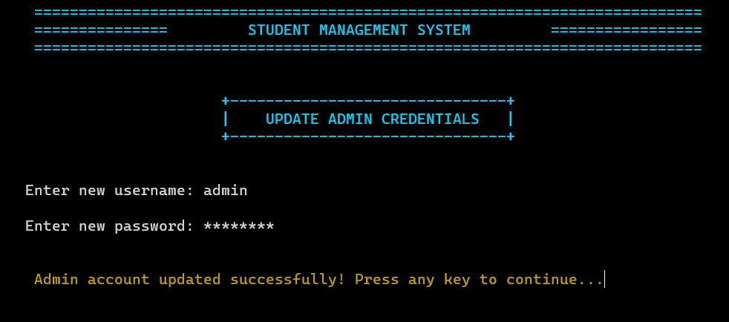

**Teacher Login**

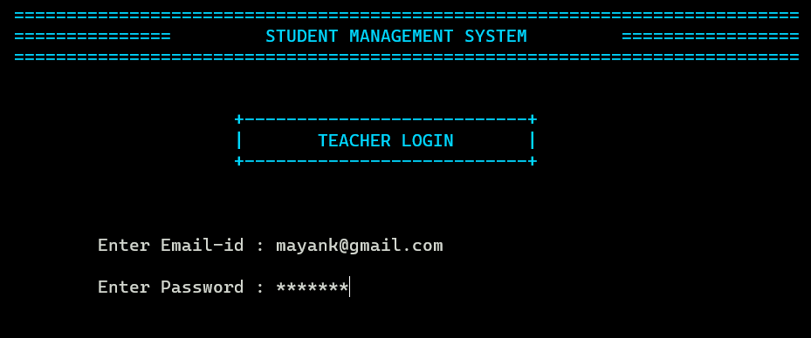

**Teacher Dashboard**

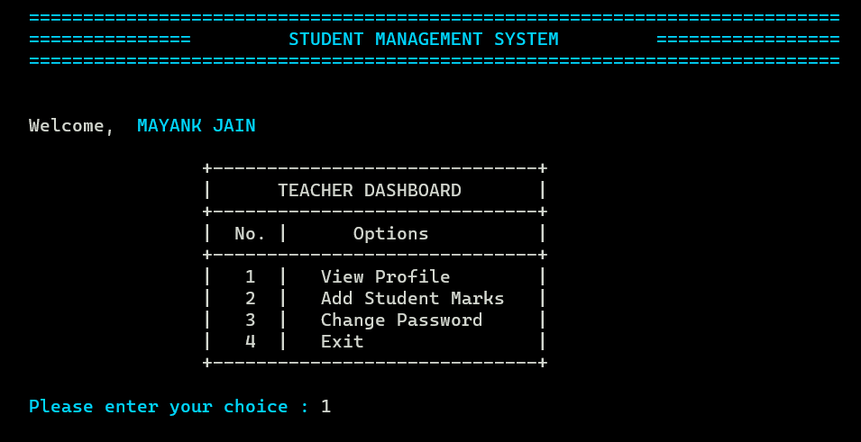

**Teacher Profile**

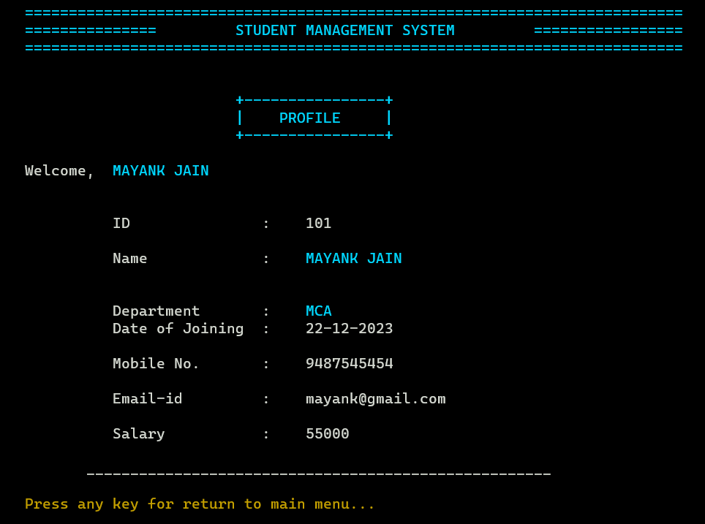

**Add Student Marks**

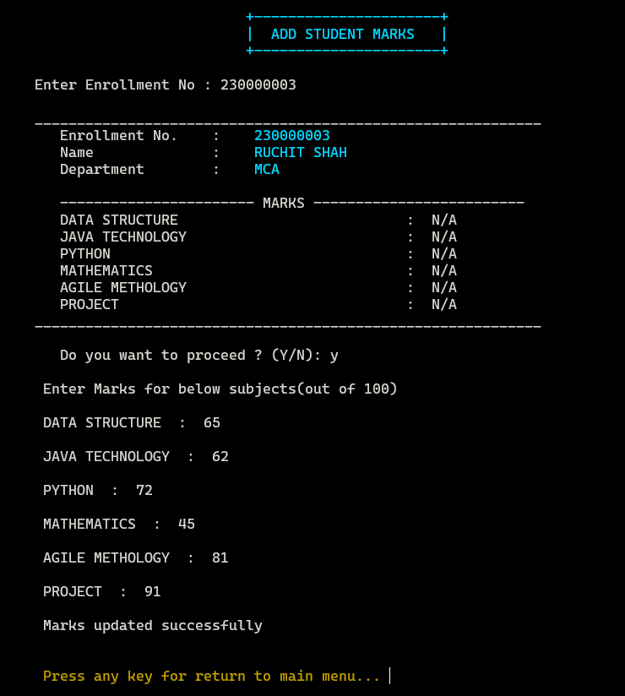

**Update Student Marks**

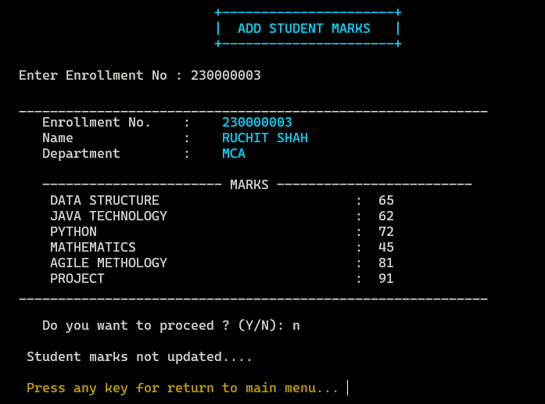

**Add Student Marks**

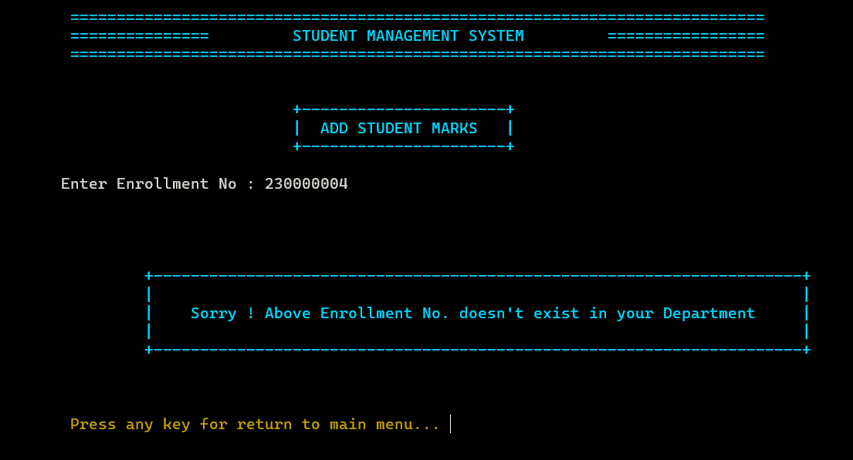

* Here Teacher can add marks of only that student which belongs to their department.

**Change Login Password**

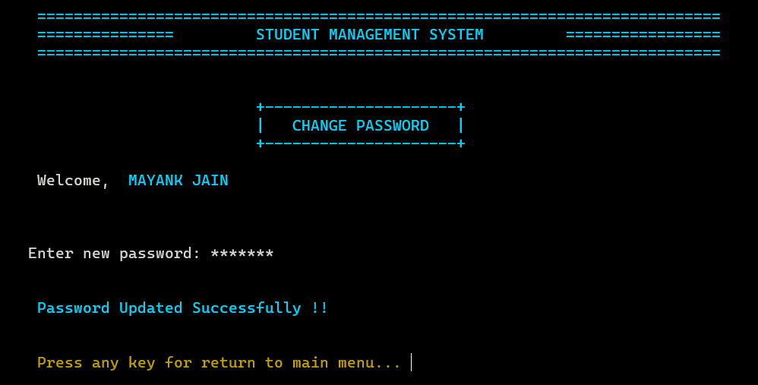

**Student Login**

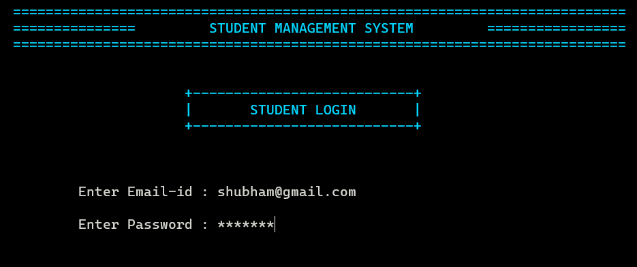

**Student Dashboard**

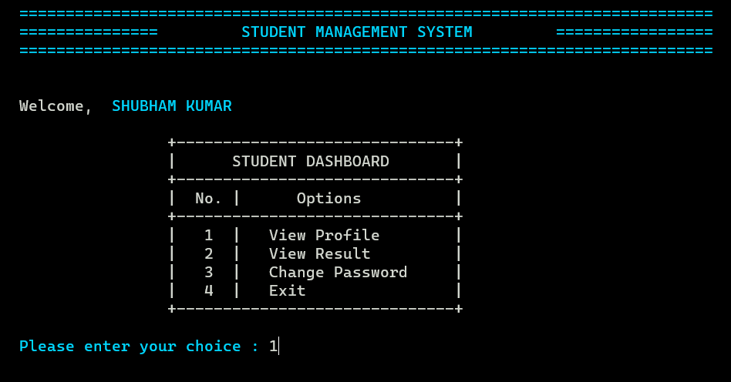

**Student Profile**

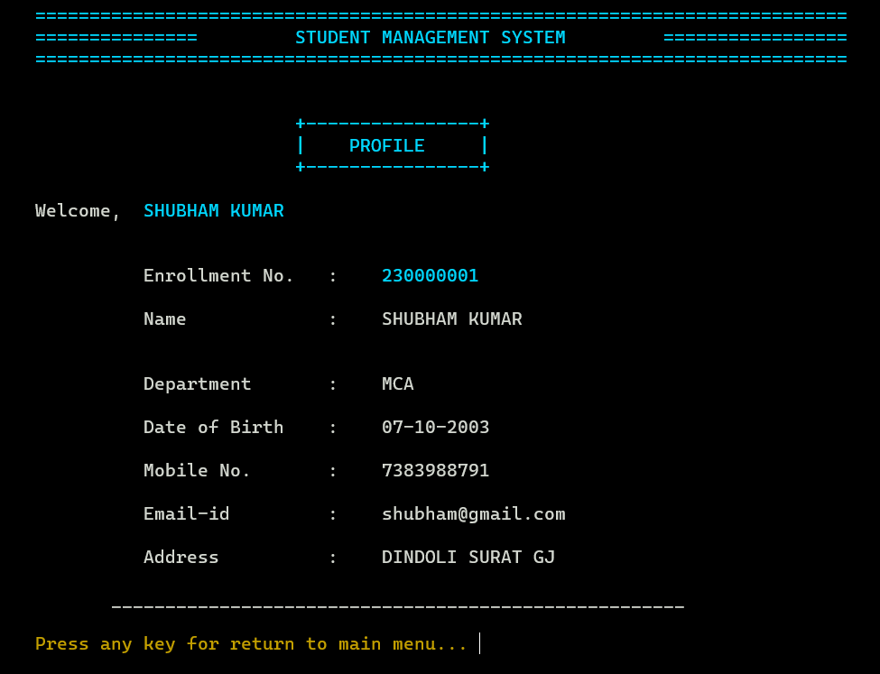

**Change Login Password**

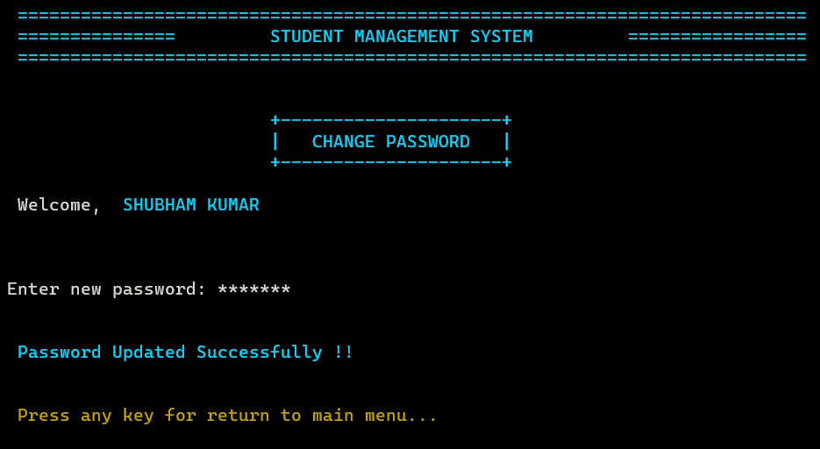

**View Result**

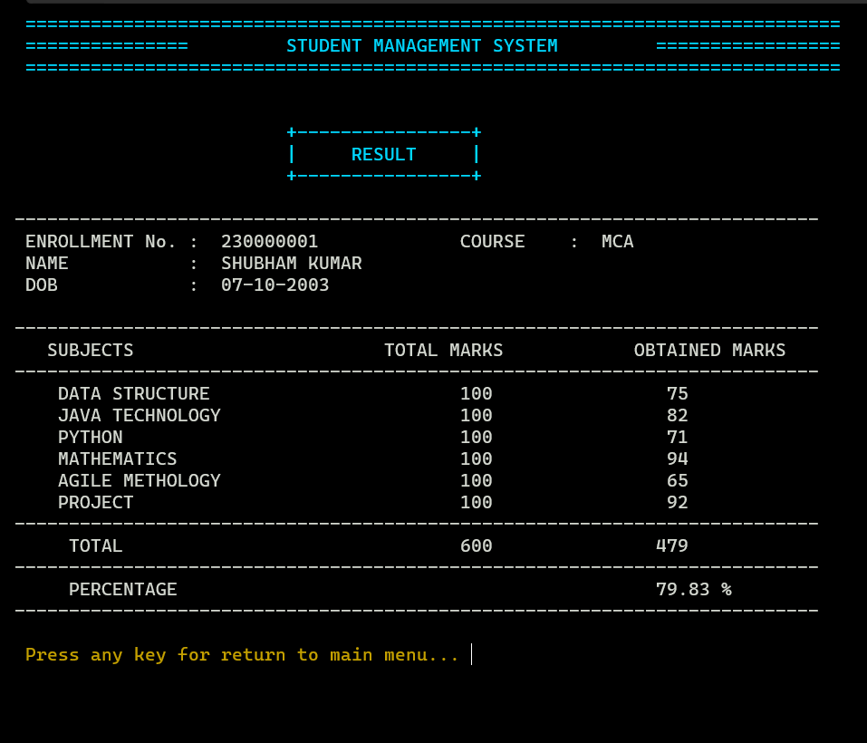

**View Result**

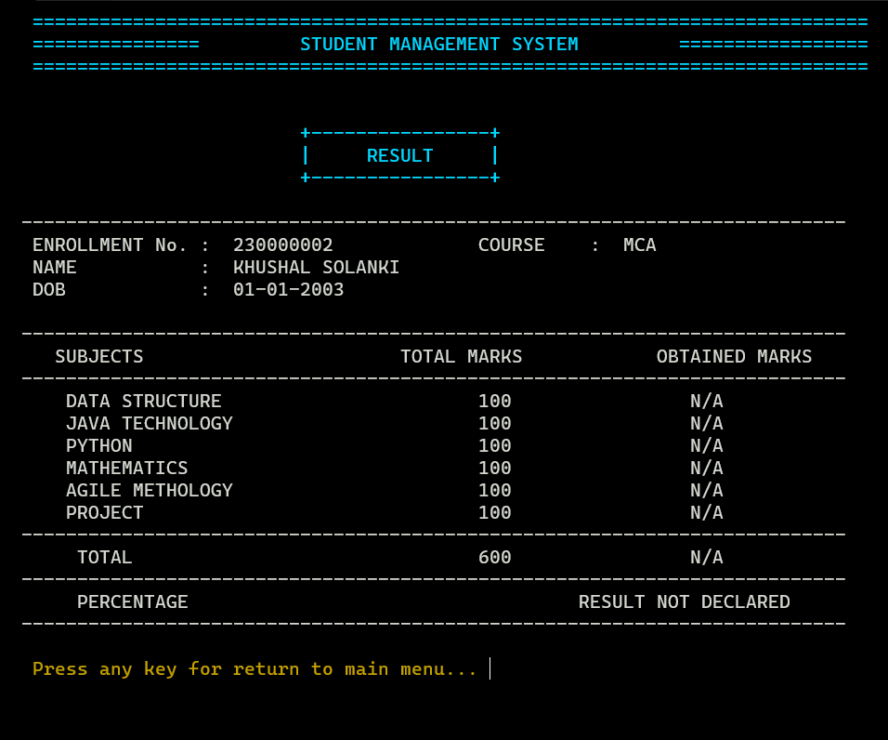

**View Result**

